AVP REPORT FACTORY FRAMEWORK Setup GUIDE

Developed by IBM Bigfix AVP

September 28, 2016

## Overview

The AVP Report Factory requires some file setup on the web reports server, as well as adding the report through the browser. You have been provided with a zip file that contains 2 files and 1 folder. This document will guide your through the setup of these files and folders to load up the report factory.

## Reference Files and context

|  |  |  |  |
| --- | --- | --- | --- |
| Component | File\Folder Name | File or Folder | Purpose |
| Supporting Libraries | Lib2 | Folder | Provides the required JS libraries for this report. |
| External Loader | External_loader.js | File | File that allows customization and extension of the framework to accommodate specific organization reports. Note the name of your file will differ. |
| Main Report Script | RFv%version%.js | File | File that contains the main codebase of the framework. Modifications to this file are not supported. External integrations and extentions are designed to be accomplished through the external loader js file. |

## Setup Steps

There are 3 steps required to setup the report factory. This section will document the 3 steps. It is important to note that all file and folder path names are case sensitive.

### 1. lib2 directory Setup

The lib2 folder must be moved to the following location on the Web reports server

Locate your web reports installation drive letter... For Example:

<Drive>:\Program Files (x86)\BigFix Enterprise\BES Server\BESReportsServer\

The lib2 folder must be moved to create the following path...

<Drive>:\Program Files (x86)\BigFix Enterprise\BES Server\BESReportsServer\wwwroot\Custom\lib2

See the following screenshot to verify setup.

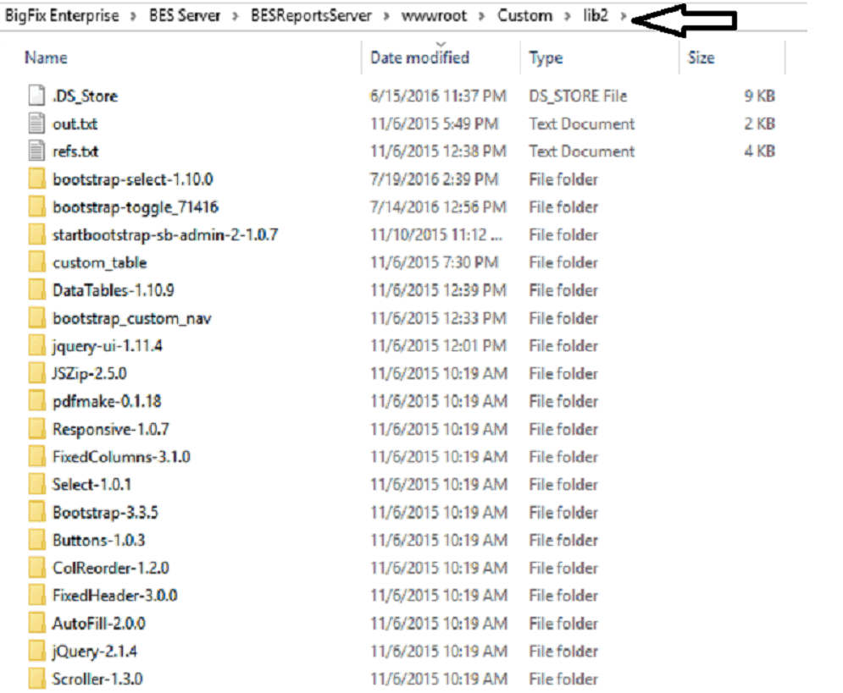

### 2. External Loader Setup

The external loader file will be named: %org%_external_loader.js. Do not alter the name of the file that has been provided to you.

The external loader file must be moved to the following location on the web reports server.

<Drive>:\Program Files (x86)\BigFix Enterprise\BES Server\BESReportsServer\wwwroot\Custom\RF1\%org%_external_loader.js

Create the directory path if it does not exist

### 3. Main Report file

File will be named: **RFv%version%.js**

This is a raw web report that must be created within web reports browser interface.

1. Open the RFv25.js file within notepad

2. Login to web reports

3. On the top navigation bar, click Explore Data

4. Click Custom

5. Within the iframe within the browser, paste the contents of the RFv25.js file within the iframe. and click the preview button... This will load the report into the browser session.

The report should look like this within the browser. If all went well this is what you should see the following...

